Title :

Cloud enabled vehicle theft

Team name : sparks

Done by:

Y.Triveni

K.Kaushik

S.Malavika

Abstract :

Property crimes are said to hover around 10 million annually. Of this, vehicle theft tops the list and often occurs in all parts of the world. There are so many recent technologies evolving and new methods are being upgraded to overcome this issue. The methods involved in vehicle theft detection have become aware to everyone including the burglars and they try to break the system and steal the vehicle. This paper proposes a system presenting a mechanism to minimize vehicle thefts. The system provides security by sending an alert message as soon the vehicle is stolen or moved without knowledge of owner. System also offers location updates periodically to the registered user through internet of things. This provision for theft vehicle tracking is provided by GPS technology by sending location. GSM technology is used to send an alert message to intimate the owner when the vehicle is started

INTRODUCTION:

In recent years vehicle theft has become a major issue which should be traced and detected. The safety and security of the vehicle is essential. Even there are many existing mechanisms they have some limitations and high cost. So, an efficient security mechanism is needed.

This project detects vehicle theft. Arduino is the main component which is used to interface dc motor and GPS, GSM. The place of the vehicle identified using

Global positioning system (GPS) and Global system mobile communication (GSM) with the help of Wi-Fi module ESP 8266. GPS is a space-based navigation system used to track the vehicle and it gives the location of the robbed device in all weather conditions. It gives the latitude and longitude of the device using GPS antenna. GSM is a specialized type of modem

which accepts a SIM card, and operates just like a mobile phone. It is used to provide information to the owner and alert him with a message having latitude and longitude of the vehicle. This total system is operated with a switch which is made on when we park the vehicles out. Now if the vehicle theft happened, dc motor starts and the above procedure continues and the information is posted using internet of things. This vehicle theft prevention and tracking system is used in client’s vehicle as a theft prevention and rescue device.

EXISTING METHODS

Mostly used systems are beepers, alarms, and biometrics. But, all these commercially available products are very high-priced. By using the car buzzer it’s easy to protect your vehicle from getting theft. But when your car is far away from you the buzzer or alarm detection might not be that beneficial.

Car alarm techniques are used to prevent the car theft with the help of different type of sensors like pressure, tilt and shock & door sensors. These systems however bear some limitations such as high cost, high falsealarm rate, and easy to be disabled. In order to solve these problem recent advancements in computer hardware and software have enabled automobile industry to develop affordable automated biometricsbased identification and verification systems. Many biometrics, including face detection, facial features, hand geometry, handwriting and voice have been used for the identification and verification of individuals. But biometric has its own disadvantages such as the systems are not 100% accurate, they require integration and/or additional hardware and cannot be reset once compromised, you can always change your password if somebody learns it, but there’s no way to modify your iris, retina or fingerprint. Once somebody has a working copy of these, there’s not much you can

do to stay safe, other than switching to passwords or using another finger. Some of the reasons due to which vehicle protection using alarm is limited like due to longer distance (range), siren cannot be heard, most of the cars have similar sounds, and physically, alarms can be disabled on theft attempts, alarm sound can be mitigated in crowded areas.

PROPOSED METHOD :

This paper presents an IOT based vehicle theft detection system. As there are many systems used till date to detect the robbed vehicle, proposed system overcomes most of the limitations of existing systems and methods. In this mechanism as soon as the dc motor starts i.e., vehicle theft occurs, Arduino activates GPS, GSM and sends an alert message to the owner and the longitude and latitude readings of vehicle are posted using internet of things with the help of Wi-Fi module. The entire mechanism can be operated with a switch for user convenience

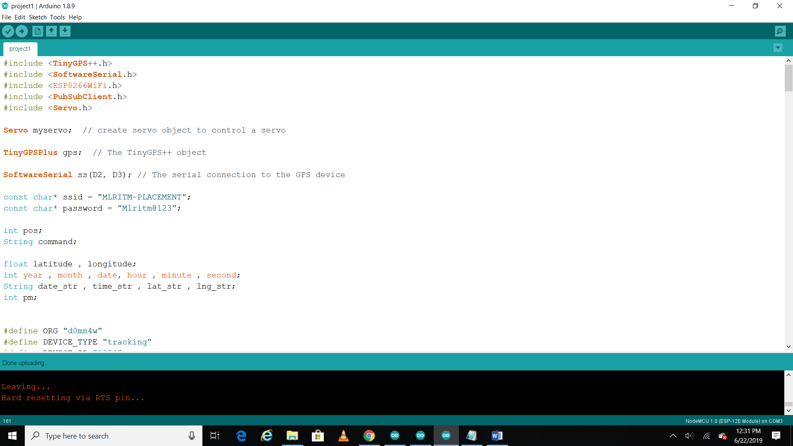

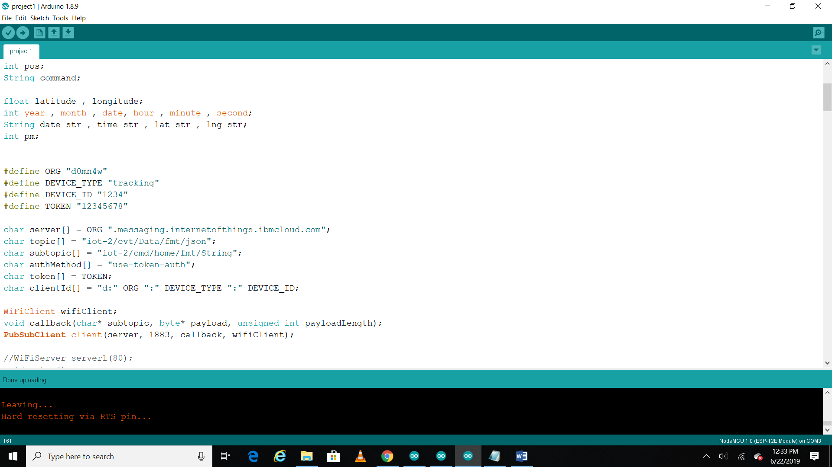

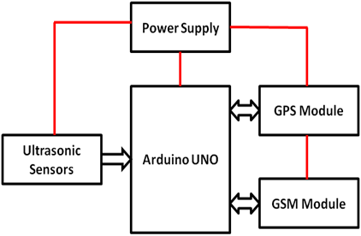

Hardware components:

NodeMCU:

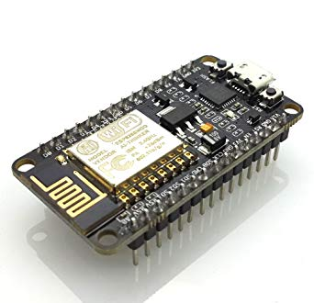

NodeMCU is an open source IOT platform. It

includes firmware which runs on the ESP8266

WIFI SOC from Espressif Systems, and hardware which is

based on the ESP-12 module.

The chip first came to the attention of western makers in

August 2014 with the ESP-01 module, made by a third-party

manufacturer Ai-Thinker. This small module allows

microcontrollers to connect to a Wi-Fi network and make simple

TCP/IP connections using Hayes-style commands. However, at

first there was almost no English-language documentation on

the chip and the commands it accepted. ]  The very low price and

the fact that there were very few external components on the

module, which suggested that it could eventually be very

inexpensive in volume, attracted many hackers to explore the

module, chip, and the software on it, as well as to translate the

Chinese documentation.

The ESP8285 is an ESP8266 with 1 MiB of built-in flash,

allowing for single-chip devices capable of connecting to Wi-Fi.

The Arduino Uno R3 is a microcontroller board based on the ATmega328. It has 14 digital input/output pins (of which 6 can be used as PWM outputs), 6 analog inputs, a 16 MHz crystal oscillator, a USB connection, a power jack, an ICSP header, and a reset button. Arduino when connected to a computer with a USB

C. DC Motor:

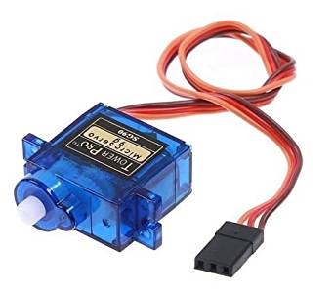

Most common type of motor. DC motors normally have just two leads, one positive and one negative. If you connect these two leads directly to a battery, the motor will rotate. If you switch the leads, the motor will rotate in the opposite direction.

D. Switch:

This is used to activate the entire theft detection system. As long as switch is in ON position SMS alert and location will be sent to owner as soon as vehicle starts. If the switch is OFF, no alert will be sent and location details are also not shared. In this way, using switch we can control system activation and deactivation.

E. GPS (Global Positioning System):

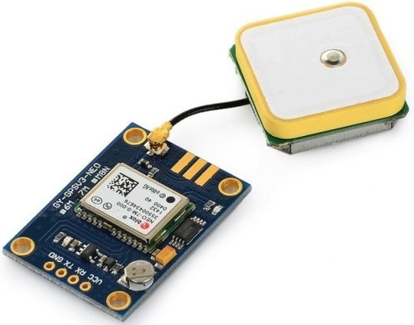

Global Positioning System (GPS) is a satellite-based navigation system. We use NEO-6M GPS module as it is compatible with a variety of GPS receivers. It has a built-in ceramic antenna. Integrates with a 3V button battery. Normally GPS works in any weather conditions at anywhere in the world. A GPS receiver must be locked on to signal of at least 3 satellites to estimate 2D position (Latitude and longitude).

F. GSM (Global System for Mobile Communications):

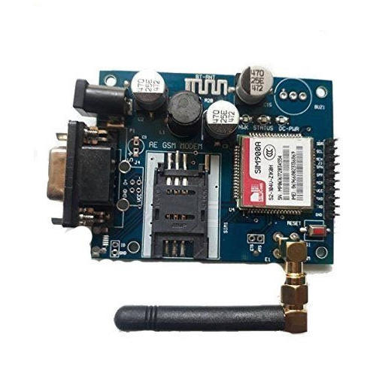

GSM is a specialized type of modem which accepts a SIM card, and operates just like a mobile phone. Here we are using SIM 900A GSM module. SIM900A Modem is built with Dual Band GSM.

The below figures show the circuit and alert message received as soon as the motor starts and location of the vehicle can also be sent in messageand the vehicle longitude and latitude readings are also posted using internet of things

Vehical tracking using gsm and gps:

This project mainly works on GPS and GSM systems. The vehicle is traced by using information from satellite systems and send to GSM systems.

Vehicle and user are connected initially by using GSM network. the user will send message to Moving vehicle for connectivity, hardware mounted on vehicle reacts to message and send conformation message to user and then if the message is valid one then GPS modem is initiated and requested for location.

The latitude and longitude values are compared with the values stored in the memory and corresponding location name is given to the Controller which in turn uses GSM/GPRS to send the location name by means of Short Message Service back to USER.

PROCEDURE FOR MIT APP :

Login to your IBM cloud account.

➢ Launch NODE-RED which is IBM

Watson IOT platform.

➢ Create a user interface between

Watson service and the device.

➢ Open MIT app inventor and create a

mobile application for your

respective project.

➢ After dumping the code in the

NODE MCU ,install the app (MIT

application) which helps you in

“TRACKING THE LOCATION”

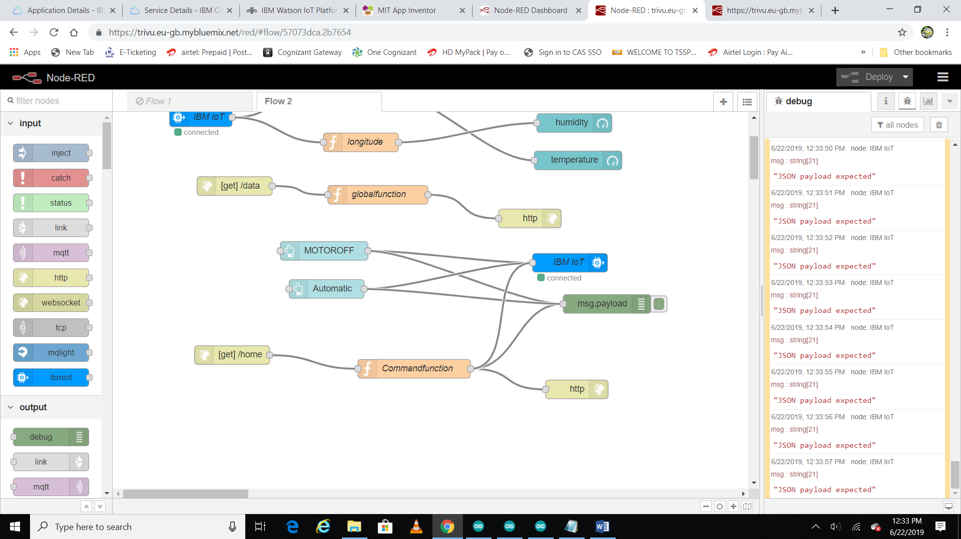

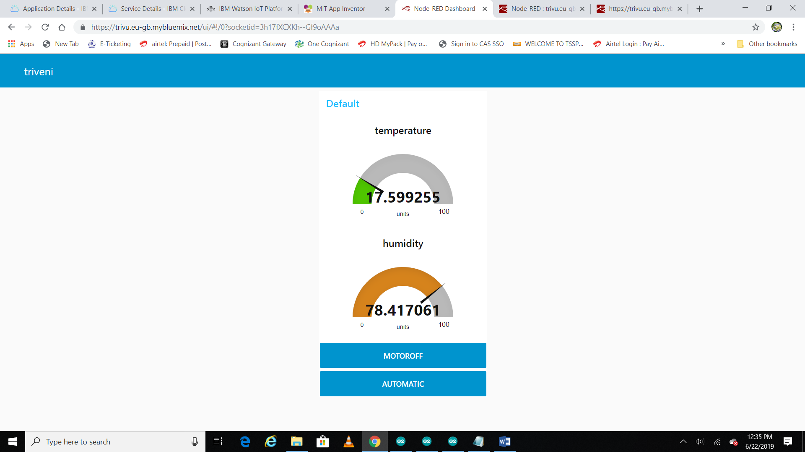

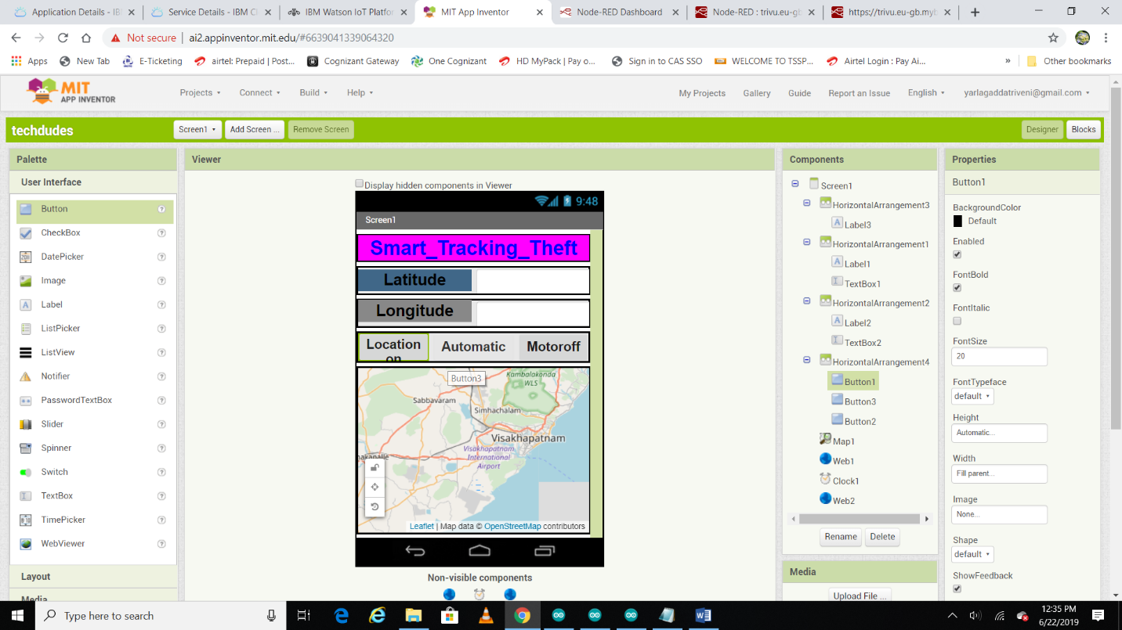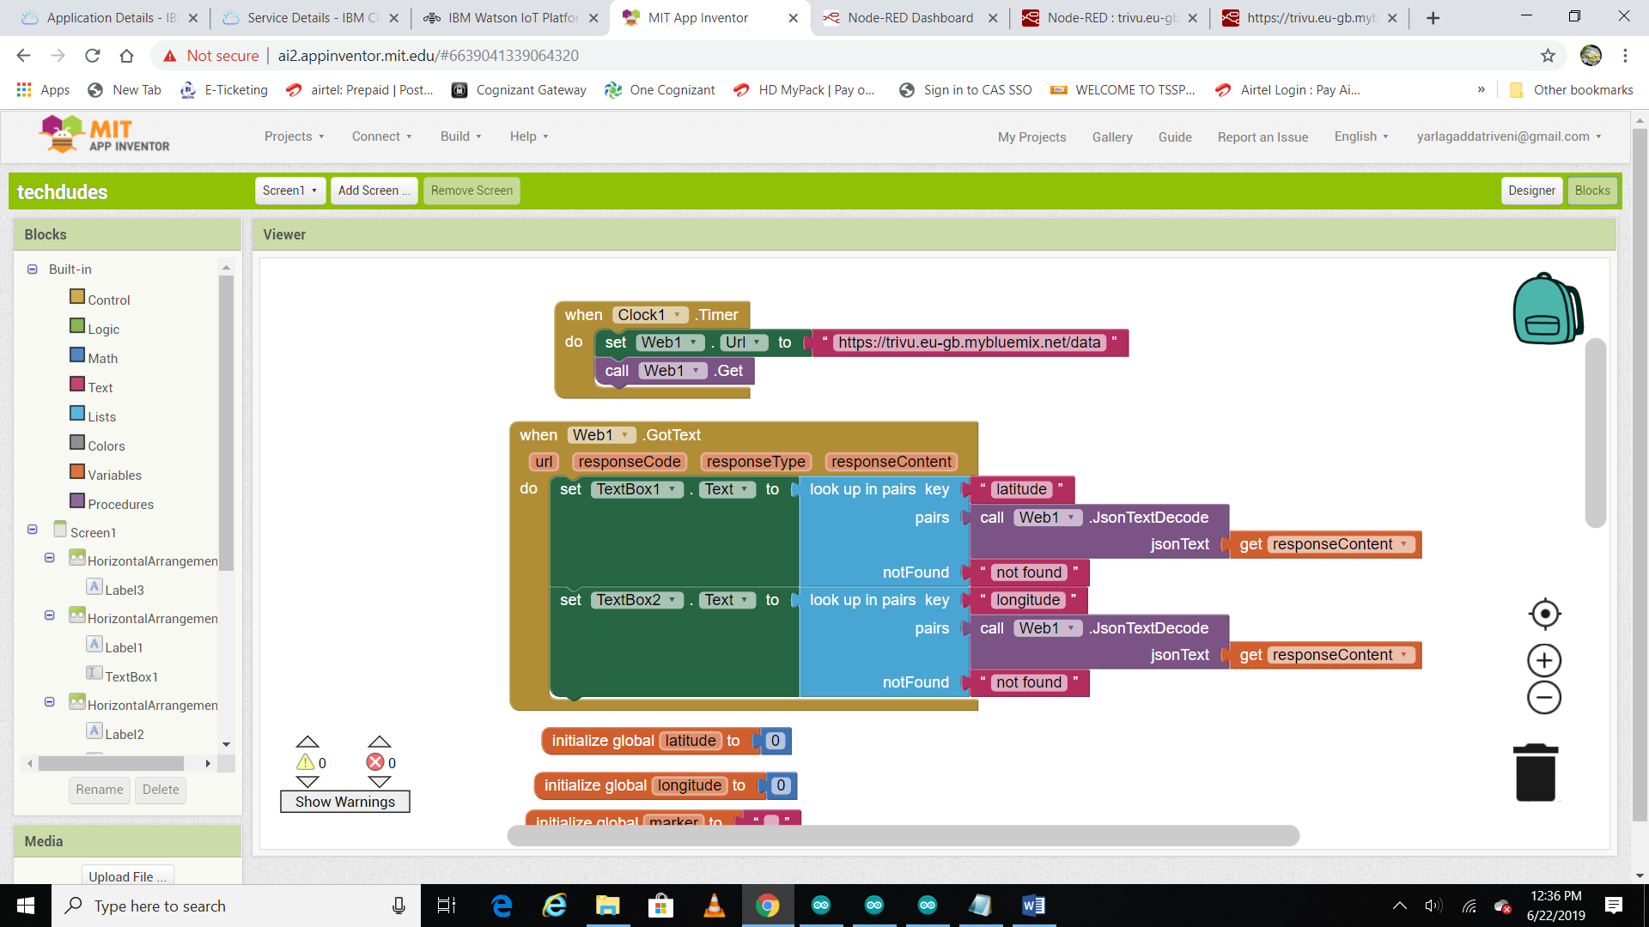

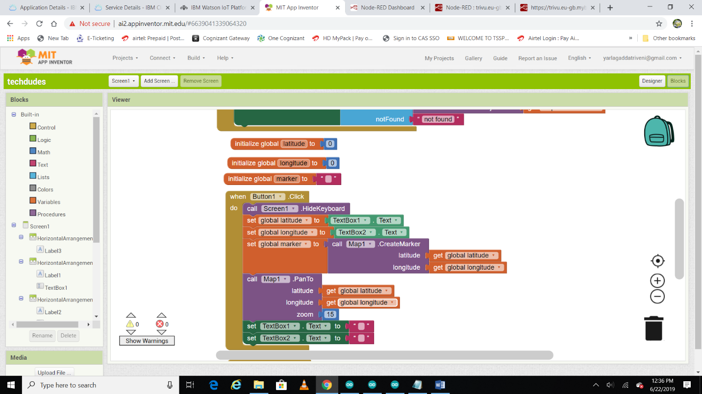

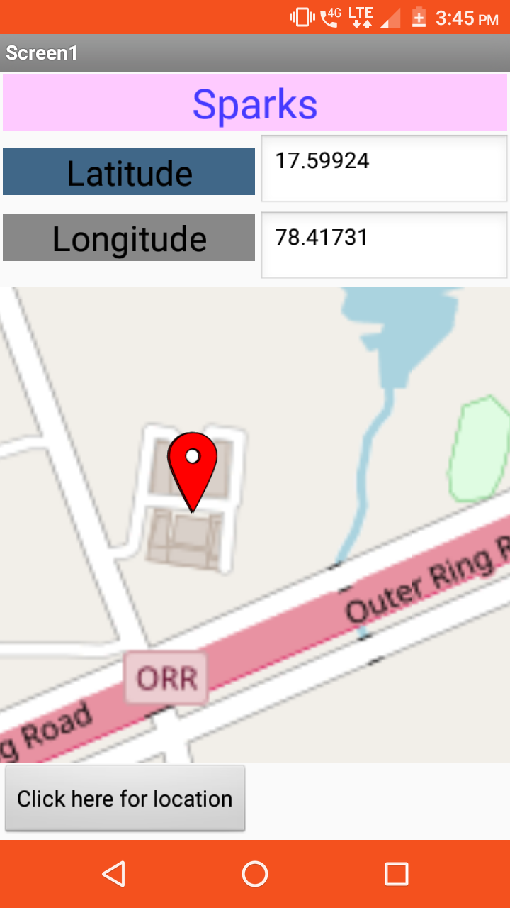

Thank you!!!